**Dynamic simulation of Microbial Electrosynthesis Systems (MES)**

**Jhuma Sadhukhan**

**Background**

Microbial electrosynthesis systems (MES) are a technology for simultaneous removal of chemical oxygen demand (COD) or impurity in wastewater in anode chamber and synthesis of products in cathode chamber by harnessing oxidation and reduction (redox) reactions by the application of an electric field between an anode (positive electrode) and a cathode (negative electrode). Electrogenic bacteria harvest electrons utilising organic or heavy metal impurity present in wastewater as substrate in anode chamber. This way, COD of wastewater can be lowered. Organic if present in wastewater as impurity can be oxidised into carbon dioxide/biocarbonate ion, proton and electron, while heavy metals if present in wastewater as impurity can be oxidised into metal cation and electron in the anode chamber. These are flown to the cathode chamber. Carbon dioxide/biocarbonate ion can be reduced in the cathode chamber in the presence of proton to synthesise volatile fatty acids, of which, formic acid, acetic acid, propionic acid, butyric acid, valeric acid and caproic acid are the products of interest from MES. Alternatively, if metal cations are generated from wastewater with heavy metal impurity in the anode chamber, they combine with electrons or can be reduced for the recovery of metals in the cathode chamber. The process offering such redox reactions are known as MES. Figure 1 shows MES schematic.

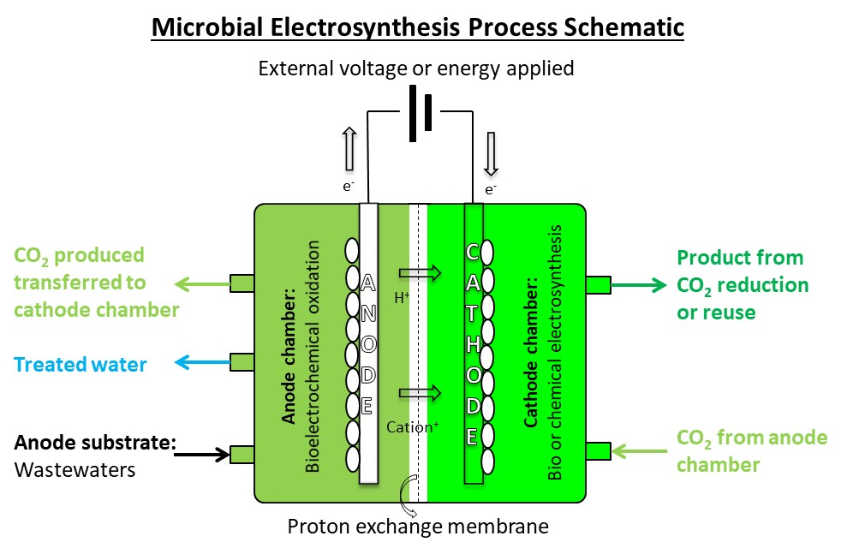

Figure 1. MES schematic for CO2 reduction or reuse into product synthesis.

Here, the coupled ordinary differential equations for MES are shown in Equations 2-10. Parameters that are applicable for the synthesis of acetic acid are built in within the equations [1]. For any other volatile fatty acid synthesis, the parameters need to be updated based on model fitting of the experimental data. Both the anode and the cathode are bio-catalysed. The equations apply mass and energy balance equation for each main component in the anode and the cathode chamber. The main components are substrate, primary product, secondary product and mediator (only responsible for electron transfer). Thus, the anode and the cathode have three mass balance equations each for substrate, primary product and secondary product. The energy conservation equation is around the mediator that is responsible for the redox reaction, i.e. transfer of electron from anode to cathode. Thus, there is one energy conservation equation involving the mediator in each of the anode and the cathode chambers. The final equation is on the production rate of the main product from the cathode that is proportional to the electron flow and hence, the mediator.

In overall reaction model, growth rates are expressed as specific growth rate of microbial system *μ*. The Monod kinetic equation is used to describe the growth of a single microbial culture limited by substrate concentration. The model is expressed as in Equation 1

$μ=\frac{μ_{max} S}{K_{s}+S}$ Equation 1

where $μ$ = specific growth rate of microbial system (h−1)

= maximum achievable growth rate (h−1)

*=* substrate concentration (g L−1)

= saturation constant (g L−1) corresponding to the concentration of the rate-limiting substrate when $μ$ = 0.5 $μ_{max}$

The parameters $μ_{max}$ and $K_{s}$ can be estimated from specific growth rate data as a function of substrate concentration during the exponential growth phase. This simplified model can be extended to substrate mixture and mixed microbial cultures. The above explanation is available in [2].

*Equations for the anode chamber*

Equation 2 shows the decreasing concentration of anode substrate with respect to time, due to its consumption by primary product producing microbial system (the first term on the right hand side) and by secondary product producing microbial system (the second term on the right hand side). Equation 3 shows the change in concentration of primary product with respect to time, due to the growth rate of the primary product producing microbial system and decay rate of the microbial system due to inhibition effects.

For the primary product producing microbial system, both the substrate consumption rate and the primary production rate are limited by the substrate and mediator concentrations. Hence, multiplicative Monod kinetic equation is used to capture the effects of limiting substrate and mediator concentration on the substrate consumption rate and the primary production rate (the first term in Equations 2-3 on the right hand side).

$\frac{da}{dt}=-\frac{1.5abd}{\left(0.5+a\right)\left(0.04+d\right)}-\frac{0.01ac}{0.1+a}$ Equation 2

$\frac{db}{dt}=\frac{0.2abd}{\left(0.5+a\right)\left(0.04+d\right)}-0.05b$ Equation 3

Equation 4 shows the change in concentration of secondary product with respect to time, due to the growth rate of the secondary product producing microbial system and decay rate of the microbial system due to inhibition effects.

$\frac{dc}{dt}=\frac{0.1ac}{\left(0.1+a\right)}-0.05c$ Equation 4

Equation 5 shows the change in concentration of mediator with respect to time, due to its consumption by primary product producing microbial system. The first term is due to the effect of limiting substrate and mediator consumptions and the second term is due to its electron transfer to the anode.

$\frac{dd}{dt}=-\frac{1.5ad}{\left(0.5+a\right)\left(0.04+d\right)}-\frac{0.34exp⁡(0.3236t)}{b}$ Equation 5

$a, b, c, d$ are the concentrations of substrate, primary product, secondary product and mediator in the anode chamber.

*Equations for the cathode chamber*

Equation 6 shows the decreasing concentration of cathode substrate with respect to time, due to its consumption by primary product producing microbial system (the first term on the right hand side) and by secondary product producing microbial system (the second term on the right hand side). Equation 7 shows the change in concentration of primary product with respect to time, due to the growth rate of the primary product producing microbial system and decay rate of the microbial system due to inhibition effects.

For the primary product producing microbial system, both the substrate consumption rate and the primary production rate are limited by the substrate and mediator concentrations. Hence, multiplicative Monod kinetic equation is used to capture the effects of limiting substrate and mediator concentration on the substrate consumption rate and the primary production rate (the first term in Equations 6-7 on the right hand side).

$\frac{df}{dt}=-\frac{1.3fgj}{\left(0.5+f\right)\left(0.002+j\right)}-\frac{0.05fh}{0.5+f}$ Equation 6

$\frac{dg}{dt}=\frac{0.18fgj}{\left(0.5+f\right)\left(0.002+j\right)}-0.13g$ Equation 7

Equation 8 shows the change in concentration of secondary product with respect to time, due to the growth rate of the secondary product producing microbial system and decay rate of the microbial system due to inhibition effects.

$\frac{dh}{dt}=\frac{fh}{\left(0.5+f\right)}-0.14h$ Equation 8

Equation 9 shows the change in concentration of mediator with respect to time, due to its consumption by primary product producing microbial system. The first term is due to the effect of limiting substrate and mediator consumptions and the second term is due to its electron transfer from the cathode to the chamber.

$\frac{dj}{dt}=-\frac{1.3fj}{\left(0.5+f\right)\left(0.002+j\right)}-\frac{0.34exp⁡(0.3236t)}{g}$ Equation 9

$f, g, h, j$ are the concentrations of substrate, primary product, secondary product and mediator in the cathode chamber.

Equation 10 assumes that the production rate of the main product from the cathode is equal to the transfer rate of the mediator.

$\frac{dk}{dt}=-\frac{dj}{dt}$ Equation 10

$k$ is the concentration of the target product from the cathode of MES.

Electrical current flow $i$ in A has been curve fitted to experimental data to obtain Equation 11 in terms of time $t$, which is then plugged into the original mediator transfer rate equations in [1] to obtain Equations 5 and 9.

$i=0.1968×e^{0.3236t}$ Equation 11

**References**

1. Gadkari, S., Shemfe, M., Modestra, J.A., Mohan, S.V. and Sadhukhan, J., 2019. Understanding the interdependence of operating parameters in microbial electrosynthesis: a numerical investigation. *Physical Chemistry Chemical Physics*, *21*(20), pp.10761-10772.

2. Sadhukhan, J. Ng, K.S. and Martinez-Hernandez, E., 2014. *Biorefineries and Chemical Processes: Design, Integration and Sustainability Analysis*. Wiley, Chichester, UK.

$$i\left(1.1+1998.9\exp\left(-0.002\left(b+g\right)\right)\right)=1-0.013(ln\left(\frac{5}{a}\right)+ln\left(\frac{5}{f}\right)+2\sinh^{-1}\left(3.165i\right))$$

i=0.1968exp(0.3236t)